AI StudyBuddy
Problem–Solution Fit
Design Validation Phase

Project | StudyBuddy
Project ID | SWTID-2026-7764
Prepared | 28 September 2026
Source | Current source folders: backend/ and client/
Document status | Project-specific draft based on current backend/client source evidence

Evidence baseline: current source files inspected from the backend/ and client/ folders. node_modules were not required. Claims not visible in source are labelled as implemented, partially implemented, proposed, unverified, or requiring verification.

Document Contents
- Fit Summary
- Problem-to-Solution Mapping
- Value Proposition
- Validation Questions

Fit Summary
The strongest fit is between the student pain of processing raw study material and the implemented pipeline that extracts content and generates multiple learning assets. The fit is weaker for cross-session notes, planner, and analytics because those frontend features are not evidenced as persisted through backend APIs.

Problem-to-Solution Mapping
User problem | Implemented solution | Fit | Evidence / caveat
Raw documents are difficult to revise | Upload PDF/TXT/MD and extract content | Strong | Multer, pdf-parse, fs reading, Material model
Manual summary writing takes time | Gemini summary endpoint and summary modal | Strong | POST /api/materials/:id/summarize
Creating practice questions is slow | Flashcards and quiz generation | Strong | Gemini-backed endpoints and UI
Students need a revision roadmap | AI study-plan generation | Medium | Backend persists studyPlan; frontend planner is local
Learning activity is fragmented | Dashboard with tabs for materials, AI, quiz, planner, notes, analytics | Medium | UI exists; persistence differs by feature
Administrators need basic oversight | Admin user/stats/delete APIs | Medium | No admin frontend evidenced

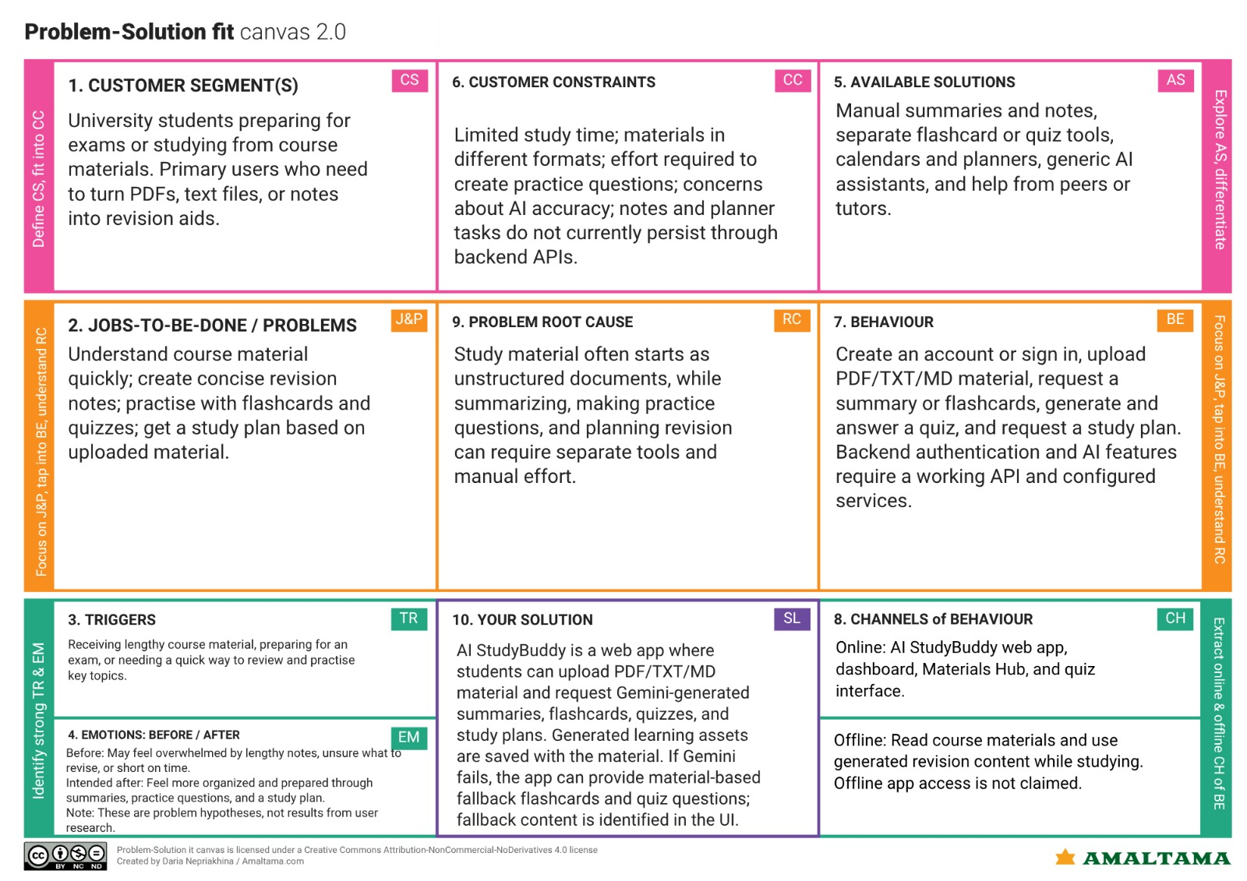Value Proposition
For university students who need to convert course material into revision-ready content, AI StudyBuddy is a document-based learning workspace that uses Gemini to create summaries, flashcards, quizzes, and study plans inside one dashboard.

Validation Questions
- Do students trust AI-generated summaries and answers enough to revise from them?
- How accurate are generated quizzes and answer keys across different subjects?
- Are locally managed notes, tasks, and analytics expected to persist across sessions?
- What maximum document length and response time are acceptable in real use?
- What administrator workflows and audit requirements are needed before production?

